Business Model: TERRA (Tracking and Environmental Real-time Response Apparatus)
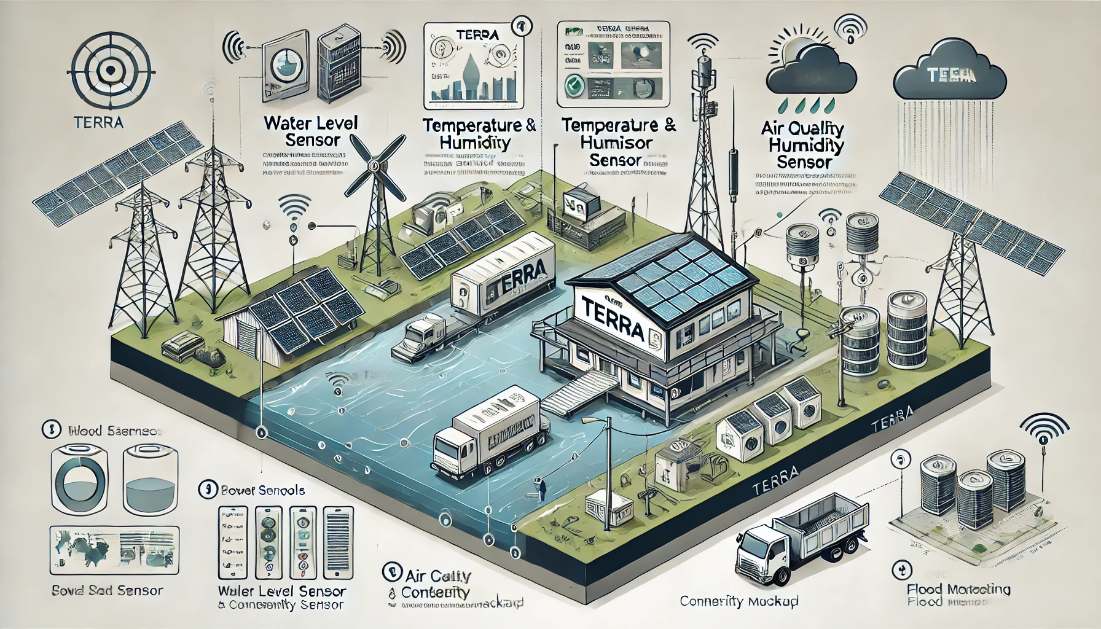

Executive Summary
TERRA is an advanced, automated flood and environmental monitoring system designed to improve flood management and response capabilities. TERRA’s innovative approach centers on real-time data gathering through automated sensors, without requiring citizen reporting. This fully automated network, capable of multiple connectivity options, provides government authorities and decision-makers with immediate situational awareness across diverse locations. Through TERRA, Bangladesh and similar regions can enhance flood resilience, protect vulnerable communities, and make informed policy and resource management decisions, fulfilling Sustainable Development Goal (SDG) 11 for sustainable urban development.

Problem Statement
Floods pose a recurrent and severe threat to Bangladesh, resulting in the loss of lives, livelihoods, and property. Traditional flood prediction systems and monitoring practices are often inadequate due to delays, unreliable infrastructure, and limited real-time situational awareness. Moreover, the lack of accurate, accessible flood data hinders quick decision-making, leaving communities at risk. These limitations underscore a pressing need for a more reliable, robust solution that bridges communication gaps and informs rapid, data-driven responses to flooding.

Solution
TERRA provides a powerful, automated network of environmental sensors designed to capture key flood-related data—such as water level, temperature, humidity, air quality, and more—in real time. By deploying TERRA devices in flood-prone areas, decision-makers gain precise and continuous situational awareness, enabling proactive, timely responses and optimal resource allocation.
TERRA’s resilience lies in its adaptability: it supports various connectivity options (Wi-Fi, GSM, 4G) and multiple power sources (battery, AC/DC adapters) to ensure uninterrupted functionality even in infrastructure-limited regions. This allows TERRA to operate consistently and reliably where conventional systems fail.

Target Market Segments

Government Agencies
  - Use case: Real-time flood data and environmental monitoring for improved infrastructure planning, disaster response, and policy-making.

Local Authorities (City Corporations, Municipalities, etc.)
  - Use case: Immediate and accurate flood response data to protect communities and mitigate disaster impacts. City cooper

NGOs (Climate, Disaster Response, and Development)
  - Use case: Access to environmental data for better resource allocation, disaster relief, and project planning.

Agriculture Sector
  - Use case: Monitoring flood risks and climate impacts to support crop planning and reduce agricultural loss.

Research & Academic Institutions
  - Use case: High-quality environmental data for research on climate change, flood patterns, and disaster resilience.

Construction and Real Estate
  - Use case: Climate data for safer site selection, planning, and flood risk assessments.

International Organizations (e.g., UN)
  - Use case: Strategic partnerships for climate resilience and global disaster mitigation initiatives.

Insurance Companies
  - Use case: Flood risk assessments to better price premiums and manage risk for clients.

Revenue Streams

Government Contracts
  - Description: Provide real-time data for urban/rural planning, infrastructure development, and flood preparedness.
  - Purpose: Act as consultants and infrastructure planners for disaster-resilient projects.

Subscription Services
  - Description: Real-time environmental data subscriptions for governments, companies, and NGOs.
  - Purpose: Enable proactive measures during climate events, helping reduce damages.

Licensing & Testing Services
  - Description: Partner with government bodies to handle environmental clearance, soil testing, and other regulatory assessments.
  - Purpose: Streamline services in collaboration with regulatory bodies.

Consultancy for Urban & Rural Development
  - Description: Provide insights for public and private infrastructure projects based on environmental data.
  - Purpose: Inform data-driven construction and urban planning to build climate resilience.

Educational Partnerships
  - Description: Collaborate with academic and research institutions for educational programs, workshops, and field studies.
  - Purpose: Foster climate and disaster education using TERRA’s real-time environmental data.

Data Analysis for Insurance & Finance Sectors
  - Description: Post-crisis financial loss assessments and real-time flood risk analysis for insurance companies.
  - Purpose: Offer precise risk evaluation to optimize financial support and resilience.

Disaster Preparedness Training Programs
  - Description: Provide training to organizations like the Red Crescent, and citizens for rescue, first aid, and crisis management.
  - Purpose: Empower local communities in disaster response and prevention.

Partnerships with Private Sector and Community Groups
  - Description: Establish partnerships with farmer co-ops, transport companies, and supply chains.
  - Purpose: Provide crop monitoring and logistics planning services during crises to ensure efficient distribution.

Emergency Kit Sales
  - Description: Supply affordable, essential emergency kits to communities and disaster-prone areas.
  - Purpose: Mitigate the impact of price hikes from syndicates during crises.

Real-time Mapping for Military and Disaster Management
  - Description: Provide real-time flood maps to army, navy, air force, and disaster response teams.
  - Purpose: Enable precise, efficient response and resource deployment.

Unique Advantages of TERRA
- Automated Data Collection: Unlike other flood prediction systems, TERRA’s advanced sensors (water level, temperature, humidity, air quality) capture and transmit real-time data without citizen reporting.
- Multi-Channel Connectivity: Equipped to handle multiple network options (GSM, Wi-Fi, 4G) and power sources to maintain functionality in areas with unreliable infrastructure.
- Adaptability & Future Scalability: TERRA is designed to incorporate additional sensors (e.g., soil quality) and predictive models. This supports a complete situational analysis, empowering decision-makers to manage resources and make informed agricultural and economic decisions.
- Complete Situational Awareness: TERRA gives a real-time overview of environmental conditions, helping authorities act swiftly to protect lives and resources.

Competitive Analysis
Feature | TERRA | Traditional Systems
Real-Time Data | ✔ | ✖
Automated Reporting | ✔ | ✖
Multi-Connectivity | ✔ | ✖
Power Source Flexibility | ✔ | ✖
Full Situational Awareness | ✔ | Limited
Expansion Capability | ✔ | ✖
TERRA’s superior connectivity, real-time reporting, and adaptability to Bangladesh's infrastructural challenges make it an ideal solution. Unlike traditional systems, TERRA requires no citizen input and delivers comprehensive data directly to decision-makers, enhancing response effectiveness.

Operational Plan
- Manufacturing and Deployment: Establish partnerships with local manufacturers to produce TERRA devices at scale. Prioritize rapid deployment in high-risk flood zones.
- Data Management: Set up a central data processing unit for real-time analysis and ensure high-quality data storage.
- Customer Support: Provide 24/7 support for government and local authorities, including training sessions and maintenance checks.

Social and Environmental Impact
TERRA directly contributes to SDG 11 by promoting sustainable urban development and resilient infrastructure. Its flood management capabilities can save lives, protect property, and reduce the economic impact of floods. TERRA's data also empowers agricultural communities, enabling them to mitigate crop loss and make climate-informed decisions, further strengthening community resilience.

Risk Analysis and Mitigation
Risk | Mitigation Strategy
Power Failures | Dual power options (battery and AC/DC adapter)
Network Issues | Multi-network compatibility (Wi-Fi, GSM, 4G)
Hardware Durability | High-quality components, regular maintenance
Regulatory Challenges | Compliance with government data and environmental laws

Conclusion
TERRA offers a transformative solution to flood management challenges. By providing real-time, automated environmental monitoring, TERRA empowers decision-makers with the data needed to respond effectively and proactively to floods and other natural disasters. As Bangladesh and other regions face increasing climate risks, TERRA represents a critical tool in building sustainable, resilient communities.

